Quality Management Policy Statement
Western Electric Contractors Limited was formed in 1996 and is a principal contractor for electrical overhead powerlines, specialising in Lv and Hv overhead design, project management, installation, repair and maintenance. We offer a full turnkey solution including wooden pole removal and erection.
It is the policy of Western Electric Contractors Limited to:
• give satisfaction to our clients and all other stakeholders, always meeting and wherever possible exceeding their expectations.
• comply with all applicable legal and other requirements to which Western Electric Contractors Limited subscribe and as a minimum the Health & Safety at Work Act etc 1974, the prevention of pollution and the reduction of our impact on the environment.
• ensure that our management system provides a framework to achieve our business objectives and achieve continual improvement.
• provide all necessary resources, including equipment, infrastructure, training and competent staff to enable our objectives to be met.
• work in partnership with our suppliers, clients and all other stakeholders to achieve optimum process efficiency, effectiveness continued planned improvement and business excellence.
Objectives and targets are consistent with the stated aims of this policy to comply with all applicable requirements and the continual improvements desired.
Western Electric Contractors Limited Directors and the team have ensured that this management system policy has been implemented maintained and is reviewed for continuing suitability at the scheduled management review meetings.
This policy has been communicated to all applicable persons working for and on behalf Western Electric Contractors Limited and is available to members of the public upon request.

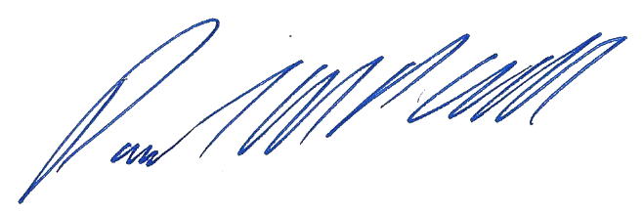
Paul Cull - Managing Director Date: - 11th March 2024

