Health & Safety Policy Statement
Western Electric Contractors Limited was formed in 1996 and is a principal sub-contractor for electrical overhead powerlines, specialising in Lv and Hv overhead design, project management, installation, repair and maintenance. We offer a full turnkey solution including wooden pole removal and erection.
As part of its commitment to the wellbeing of employees and high standards of Corporate Governance, Western Electric Contractors Limited places the Health and Safety at Work etc Act 1974 and Occupational Health & Safety considerations at the heart of its activities.
To ensure continual improvement we maintain an ongoing Occupational Health & Safety Improvement Programme in line with the Health and Safety at Work etc Act 1974. Western Electric Contractors Limited will:
• meet all relevant legislation, government guidelines, regulations, and industry codes of practice on Occupational Health & Safety issues, and where possible exceed them.
• ensure that on a continual basis Occupational Health & Safety hazards are identified, risks assessed, and suitable controls put in place to prevent injury and ill health.
• develop our management processes to ensure that Occupational Health & Safety factors are considered during planning and implementation.
• engage with employees, contractors, and visitors to further reduce Occupational Health & Safety hazards and risks associated with working for, with, or on behalf of Western Electric Contractors Limited.
• ensure that working safely is a condition of employment.

This policy has been communicated to all applicable persons working for and on behalf of Western Electric Contractors Limited and is available to all external bodies and members of the public upon request.

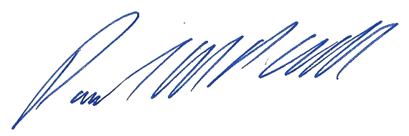
Paul Cull - Managing Director Date: - 11th March 2024

